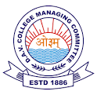 DAV PUBLIC SCHOOL NTPC FARIDABAD
CIRCULAR
Date-19.05.2023
Circular Number- Admin./2023-24/Circular -01
Classes-Nur to XII
Dear Parents
We are making Student's I- Card and Escort ID cards for parents.
You are requested to send hard copy of passport size photograph of Father, Mother and Guardian of your ward positively by tomorrow.
You can also mail the soft copies of photos of father, mother and guardian of the child to the class teacher.

Alka Arora

